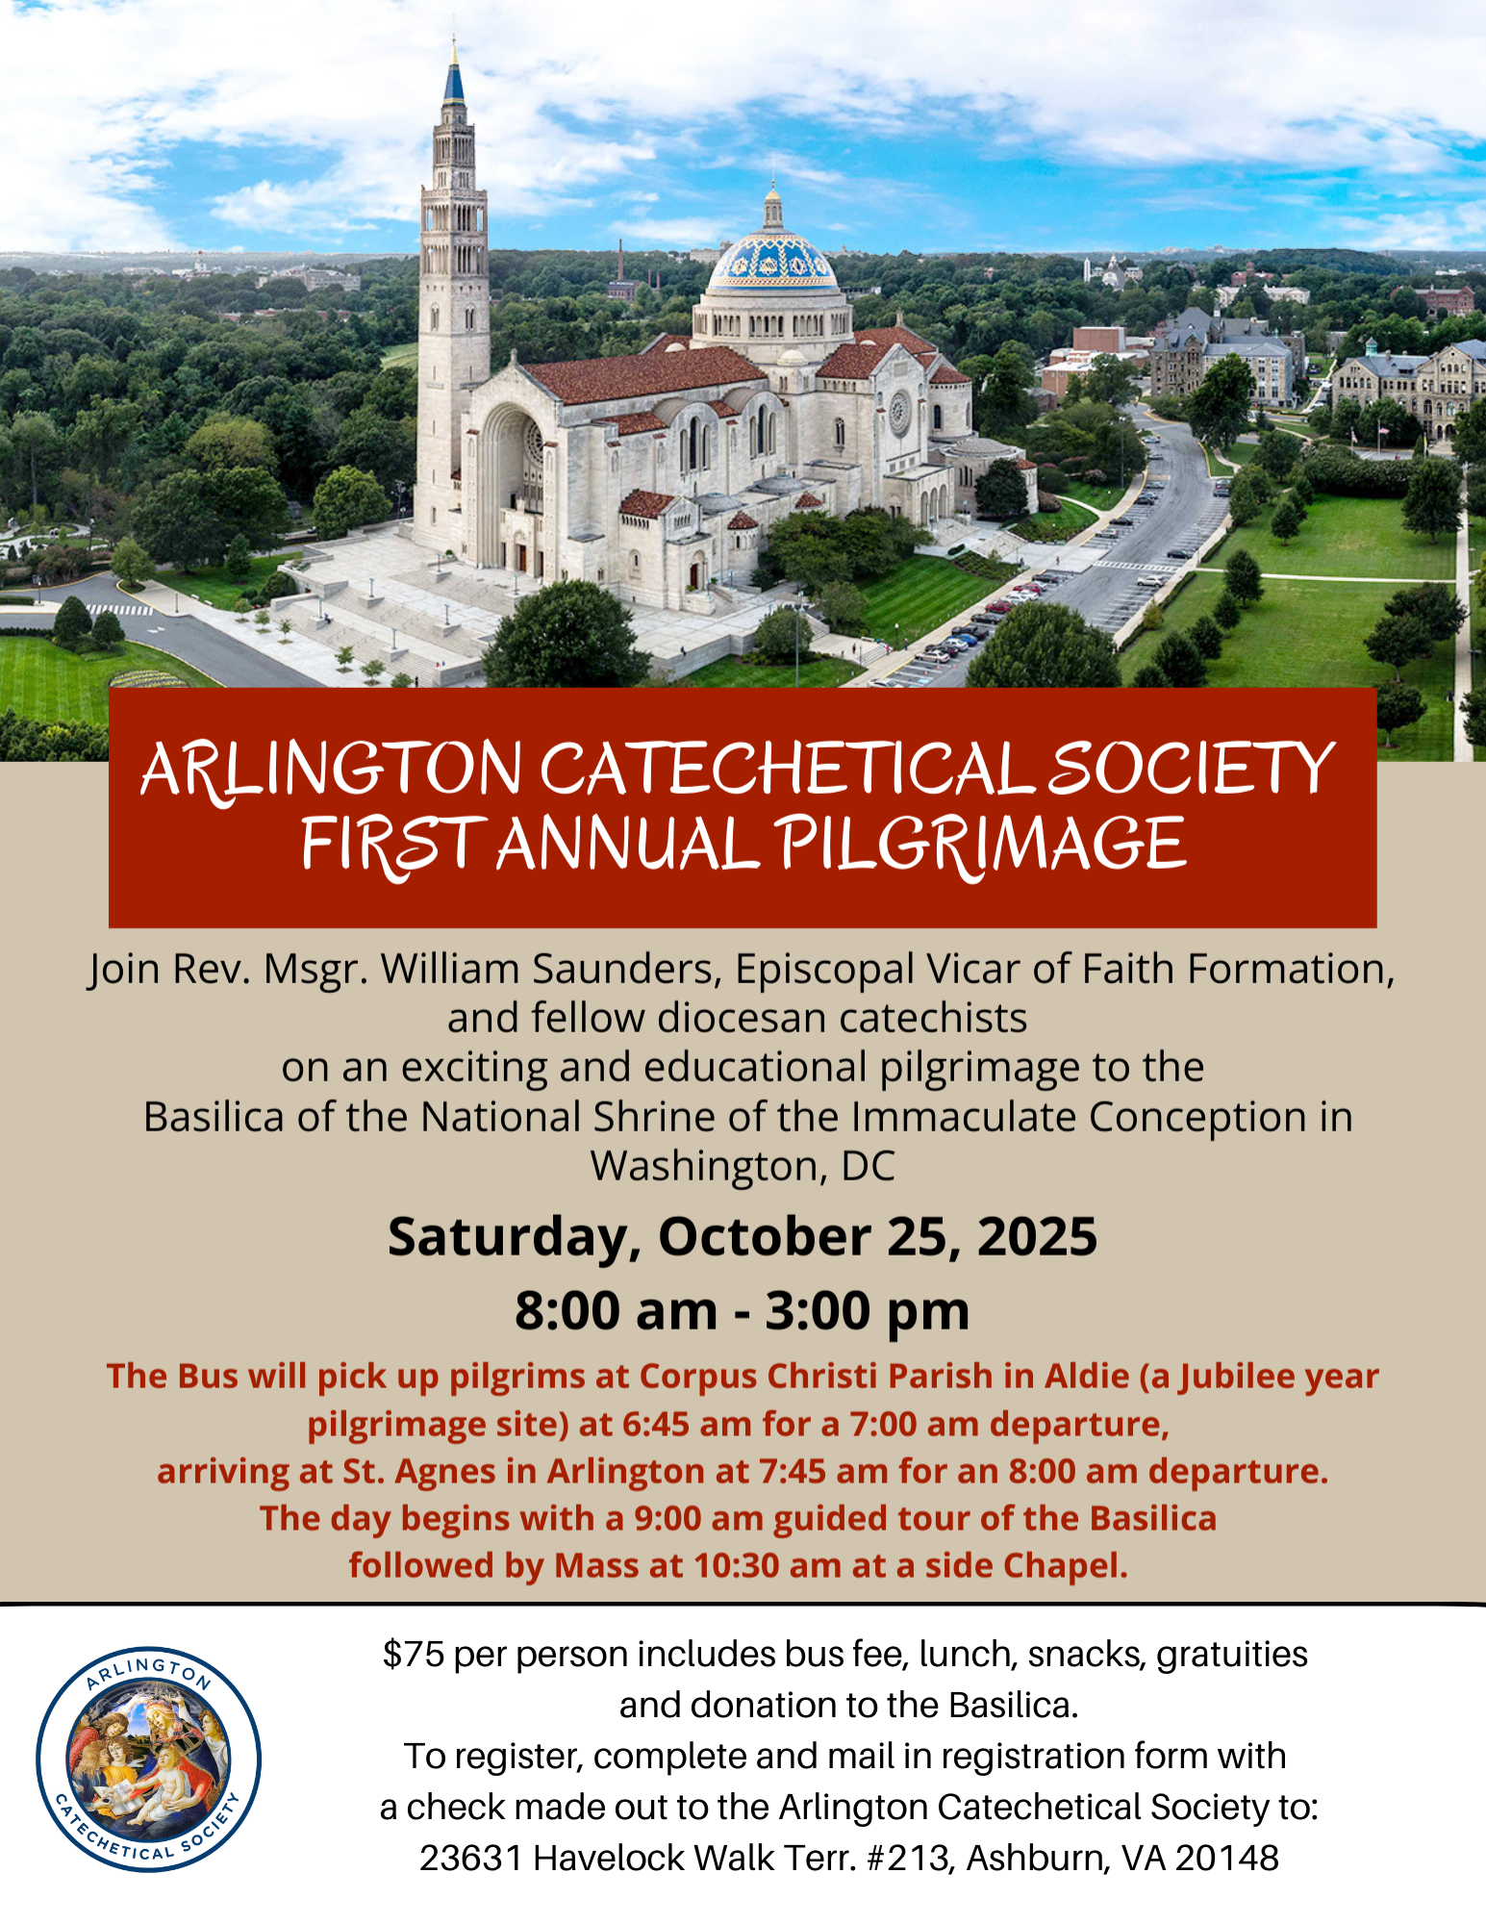
Arlington Catechetical Society First Annual Pilgrimage to the Basilica of the National Shrine, Washington, DC.
Saturday, October 25, 2025 - REGISTRATION FORM
Cost: $75 per person - includes bus fee, snacks, lunch, donation to the Basilica, and gratuities.
Participant Name: ___________________________________________________________________________
Email: ____________________________________________________________________________________
Telephone/Cell Phone: _______________________________________________________________________
Emergency Contact: ___________________________________________Tel: ___________________________
- 7:00 a.m. Bus departure from Corpus Christi Catholic Church (Jubilee pilgrim site), 41685 Corpus Christi Dr., Aldie, VA, 20105.
- 8:00 a.m. Bus departure from St. Agnes Catholic Church (Jubilee pilgrim site), 200 N. Randolph Street, Arlington, VA, 22207.
Our day will begin with a 9:00 a.m. guided tour of the Basilica.
Our day will include Mass and the opportunity for confessions.

Boxed lunch comes with sandwich, chips, fruit, cookie, water
Please choose your Sandwich Option:
- Turkey
- Ham
- Roast beef
- Chicken breast
- Chicken salad
- Tuna salad
- Vegetarian wrap
- Special Request - Gluten free lunch.

Return to St. Agnes by 2:00 p.m., and Corpus Christi by 3:00 p.m.

Please mail this completed form and attach payment made out to the Arlington Catechetical Society to:
Delores Nelson, 23631 Havelock Walk Terr. #213, Ashburn, VA, 20148

